

University of Engineering & Technology Mardan
Department of Computer Software Engineering

Submitted By | Umar Hayat
Semester | 6th, Spring 2026
Registration No | 23MDSWE274
Batch | 06
Subject | HCI Lab
Submitted To | Dr. Hamid Ullah
Lab Task # 05

Mood Board:
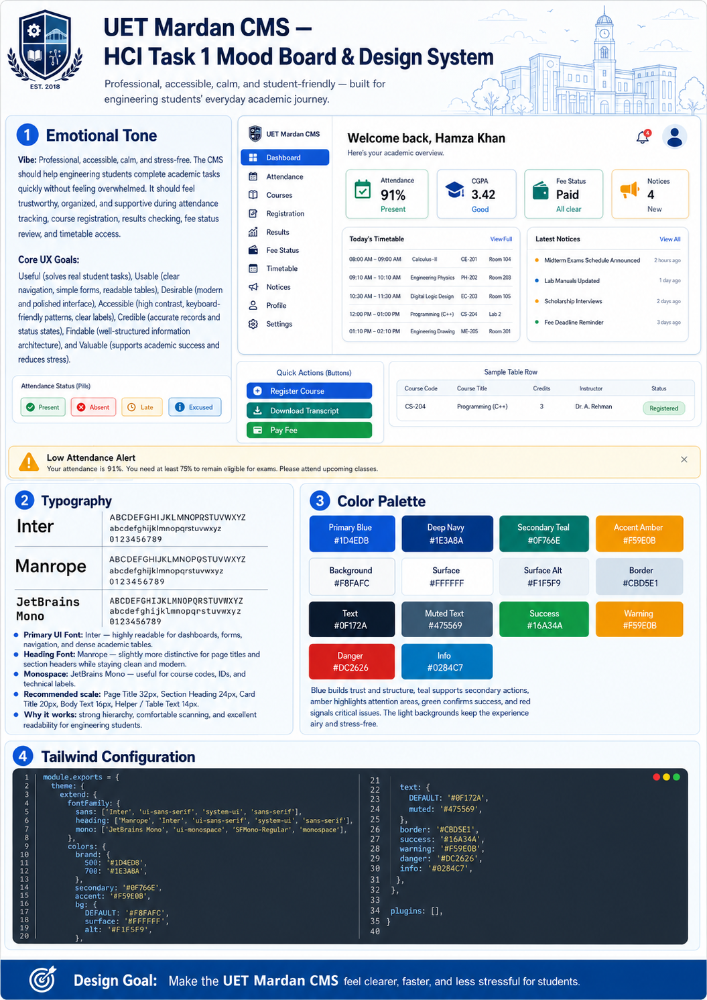

Task 2: Home Screen
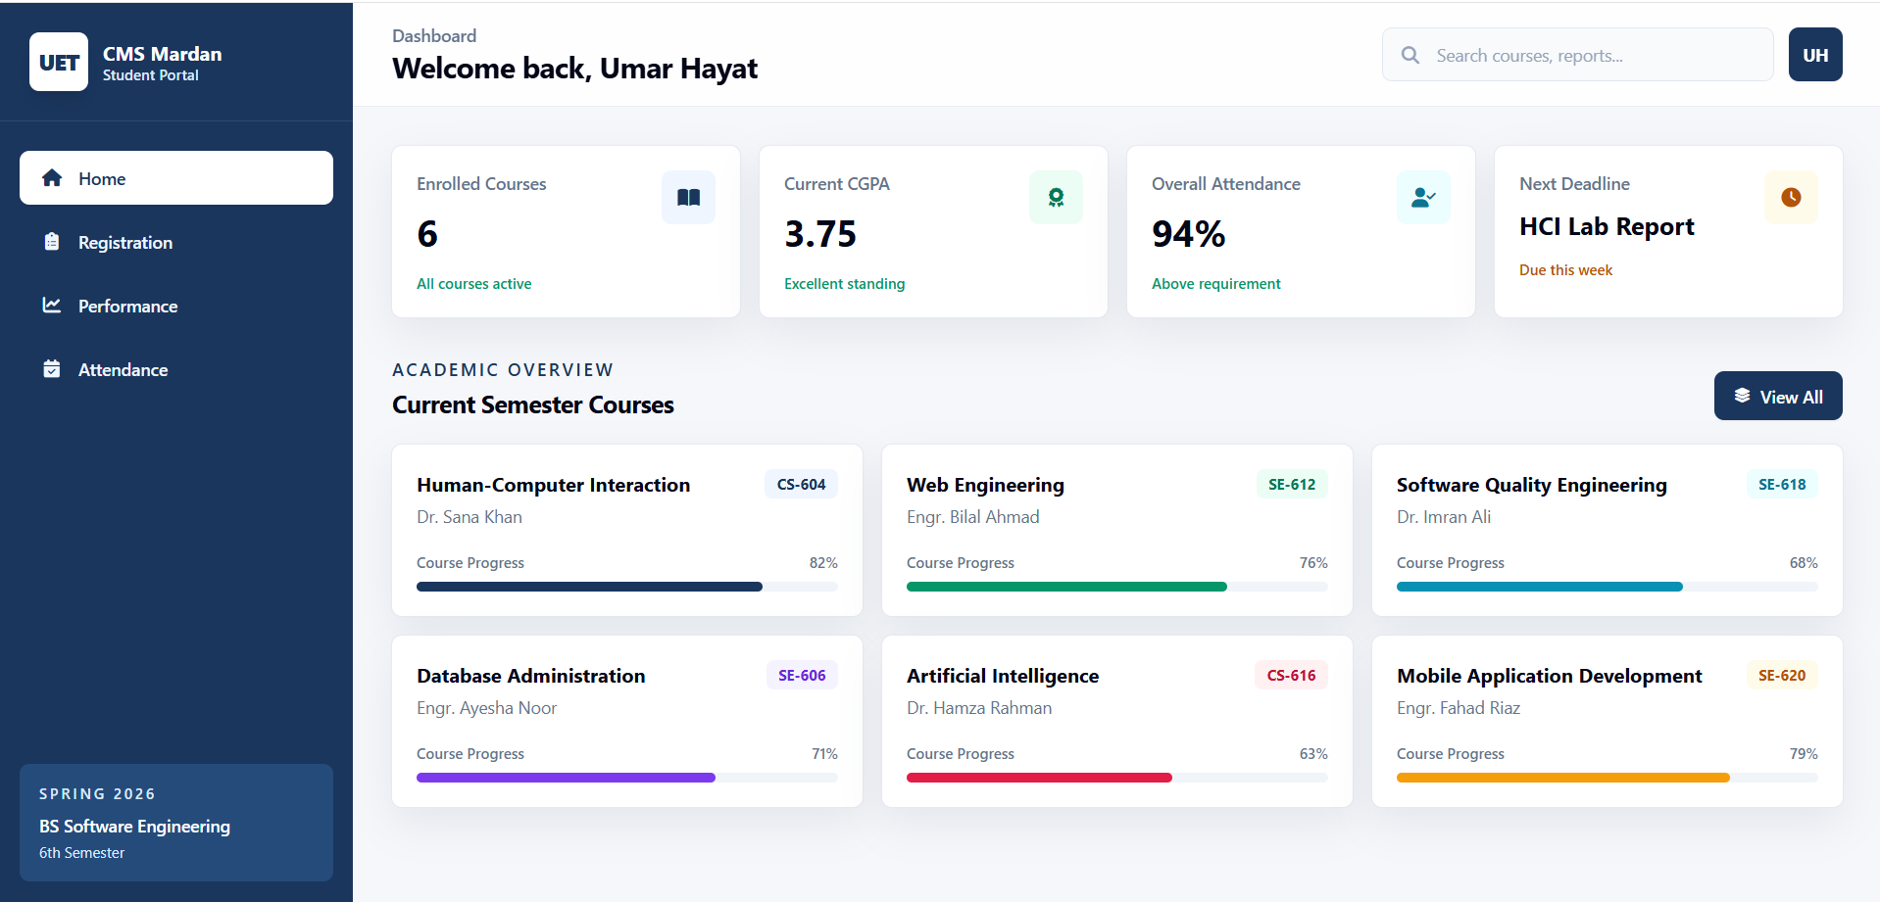
Task 2: Course Registration
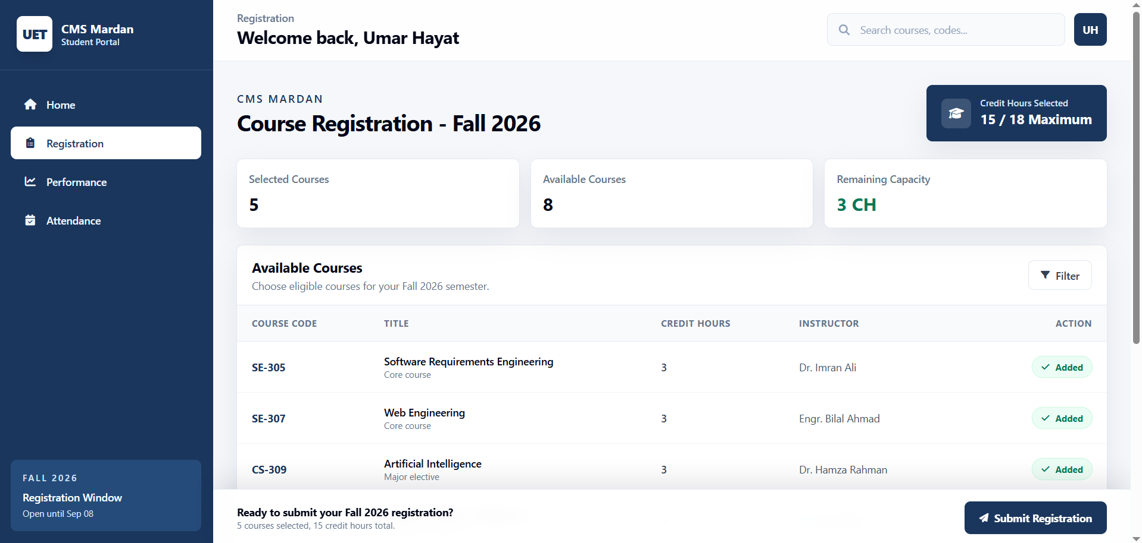

Task 2: Course Performance
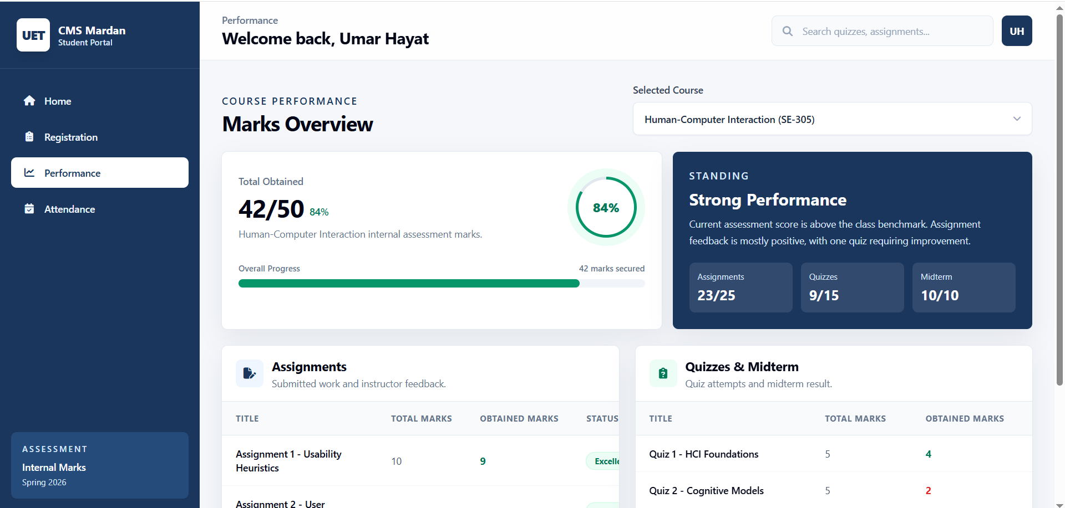
Task 2: Attendance
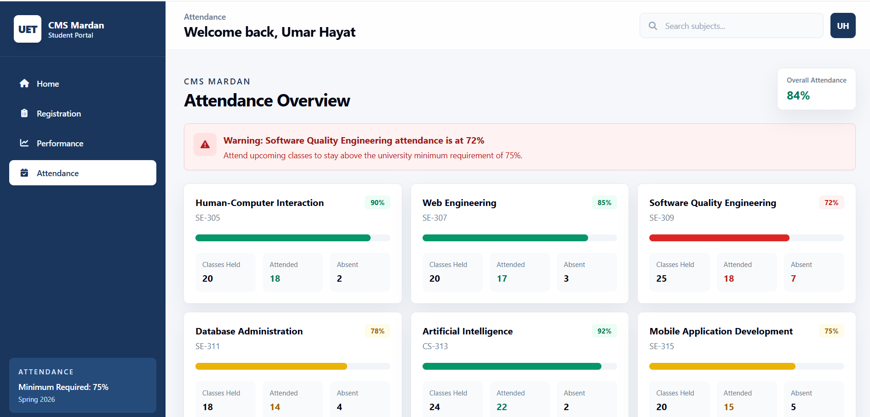
Github Repository:
https://github.com/umarhayat1651/HCI-Labs

